PhD VIVA VOCE
Candidate Name: | Geraldina Edward | 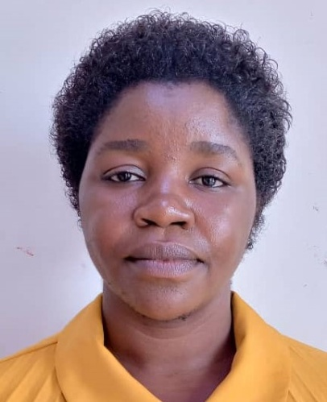
Registration Number | 2014-07-00210  University of Dar es Salaam,  School of Education
Qualifications :
1. Masters’ of Arts in Education (MA-EDUCATION)-University of Dodoma (2009-2012)
2. Bachelor of Education in Psychology (BED-PSYCHOLOGY)-University of Dar es Salaam (2005-2008)
Title of Dissertation/ Thesis: | “Social- Contextual factors Associated with Children’s Learning of Kiswahili Pre-Reading Skills in Tanzania’s Rural Public Schools”
Date of Viva Voce: | 31st March, 2021
Venue: | Board Room, SoED
Time: | 10.00 a.m.
Supervisor | Prof A.S. Mbise, M.K. / Dr. R. Shukia
Abstract:
This study investigated socio-contextual factors (SCFs) associated with children’s learning of Kiswahili pre-reading skills (PRS) in Tanzania’s rural public schools. The study was guided by the following three research objectives, which were to: examine the relationship between teachers’ pedagogical content knowledge (PCK) and children’s learning of Kiswahili PRS in high and low performing rural public schools; examine the relationship between parental involvement in academic issues and children’s learning of Kiswahili PRS in high and low performing rural public schools; and explore the perceived hindrances associated with children’s learning of Kiswahili PRS in high and low performing rural public schools. The study used concurrent triangulation mixed methods research design. In this regard, it employed questionnaires, interviews, observation, focus group discussions (FGDs), document review and children’s tests to collect data. Stratified random sampling and purposive sampling were used to obtain a sample of 350 participants, involving 20 head teachers, 20 teachers, 155 parents and 155children. SPSS programme helped to analyse quantitative data. On the other hand, qualitative data were subjected to thematic analysis using NVivo. The results show that there was no systematic match between teachers’ PCK scores and children’s performance in Kiswahili PRS, implying that teacher performance in PCK had no significant relationship with children’s
performance in Kiswahili PRS (M= 92.45, SD = 19.07); t (19) = 1.618, p&gt; .05 in both school categories. Children’s poor learning of Kiswahili PRS was associated with teachers’ lack of specialised training in pre-primary education (PPE), lack of teaching motivation, irregular teaching of Kiswahili PRS, and lack of regular internal classroom quality assurance. Moreover, the results indicate a mismatch between parental involvement in academic issues and children’s performance in the Kiswahili PRS, implying that parental involvement in academic issues had no significant relationship with children’s performance in Kiswahili PRS(M= 31.74, SD = 9.93); t (152) = 1.040, p&gt; .05 in both school categories. This was attributable to parents’ lack of knowledge on PPE, lack of parental support, and effects of the home environment. Furthermore, the results show that several perceived hindrances were associated with children’s low learning of Kiswahili PRS. These included individual factors such as children’s immaturity, poor self- learning motivation, and school absenteeism. Social factors included mother-tongue interference, poor parents-teacher collaboration, community beliefs about children’s education, and nature of
parents’ economic activities; and contextual factors like scarcity of classroom infrastructures and long distance from home to school. On the whole, poor SCFs such as low level of teachers’ PCK for Kiswahili PRS, lack of parental involvement in children’s learning issues, presence of individual, contextual and other social hindrances were associated with children’s low learning of Kiswahili PRS in high and low performing rural public schools. Thus, the study recommends for teachers to be professionally trained to teach in pre-primary schools to promote children’s
Learning. Parents should also be educated on their involvement in their children’s education. Also, pre-primary school learning environment should be improved by increasing the PPE budget to support children’s learning, particularly learning of Kiswahili PRS.

No | Name | Designation | Rank | Unit
1. | Prof. A.G. shumi | Chairperson | Professor | SoED-EFMLL
2. | Dr. Joviter Katabaro | Representing External Examiner | S/Lecturer | SoED-EPCS
3. | Dr. Mwajuma Vuzo | Internal Examiner | S/Lecturer | SoED-EPCS
4. | Prof A.S. Mbise | Candidate’s Supervisor | A/Professor | SoED- EFMLL
5. | Dr. R. Shukia | Candidate’s Supervisor | Lecturer | SoED-EPCS
6. | Dr. Wadrine Maro | Head of the relevant department (or his/her appointee) | Lecturer | SoED-EPCS
7. | Dr. A. Tarmo | Co-opted Member (appointed by College/School/Institute | Lecturer | SoED-EPC EFMLL S
8. | Dr. B. Kanukisya | Co-opted Member (appointed by College/School/Institute | S/Lecturer | SoED-EMFLL
9. | Dr. Subilaga Kyejo | Appointee of the Principal for PhD only) | Lecturer | DUCE

